**Sec definitions**

**Def in depth :** de eni a5ly feh 2 way ( factors ) authorization ( authentication ) w eni bdl bl tare2a l old w 8areeba a5ly kol haga tt authorize zi eni azbt l user wl pass w b authorization app msln w b3d kda a7ot fire walls 3nd l web server w b3deh l app server w b3d kda lw 3da mn kol da fa 5las l data tt5zn tmm fl data center bt3ty w tb2a encrypted bss

**Least Priv :** w da eni ady access ll nas 3la 7sb l roles bta3thom w kol haga tb2a specified l nas mo3ynna w b3d kol fatra a check 3lihom hal byst5dmoha w bt3 l role bt3thom wla la w a4elha w f nfs l w2t ashof l ips wl protocols l msh b7tagha 3ndy fl system a4elha brdo

**Separation of duties :** eni a5ly kol wa7d leeh door w role mo3yna y3ni msln msh l ytlob request hwa hwa l ynf3 y3ml approve la 8ero b 7es eni ab2a mt7km f kol haga w kol wa7d mtrag3 3lih mn sh5s b3deh

**Secured by Design :** eni a5ly l security integrated m3 kol step mn steps l system wt test feha b 7es enk ttl3 system w app aw deployment kawy gdn w kol 5atwa fehh mt2mna asln fa nta kda kman btmn3 l single point of failure

**Kiss ( Keep it simple , Stupid! ) :** b eni msh 3ayz a3ml system complex l2no lw complex msh hyb2a secured enough ma hyfdl brdo l bad guy , y3ni bl bldy kda so3obtha f soholtha

**Security by obscurity ( not follow ) :** eni a5ly l mechanism l bsht8l beha tb2a bayna lya eni afdl afokha bdl ma tb2a f black box ( not follow ) la tb2a f glass box ( transparrent box ) fa kda a follow

Network Sec.

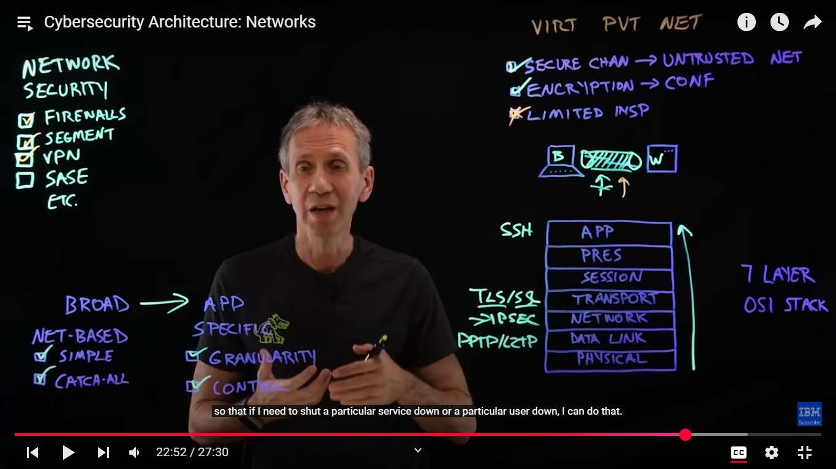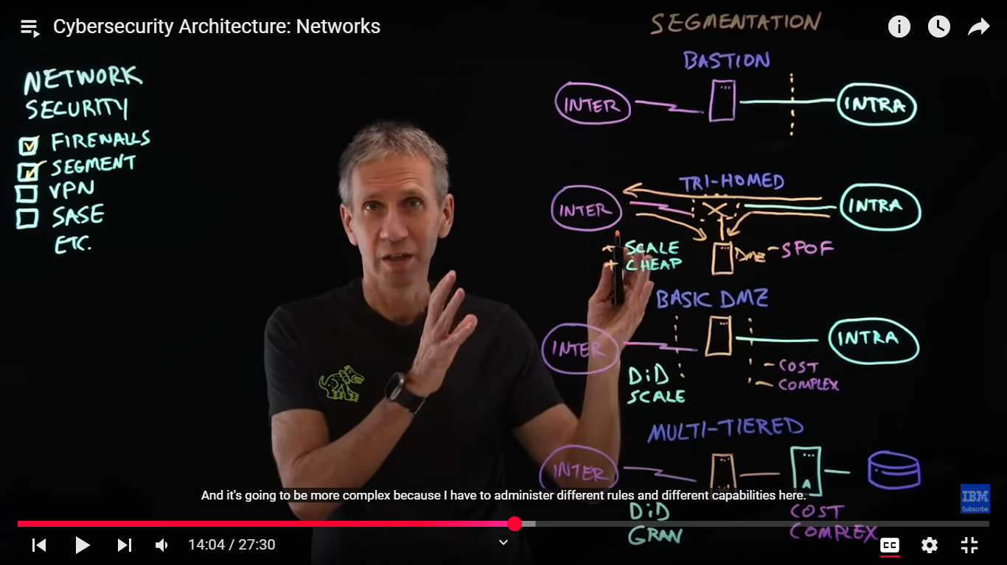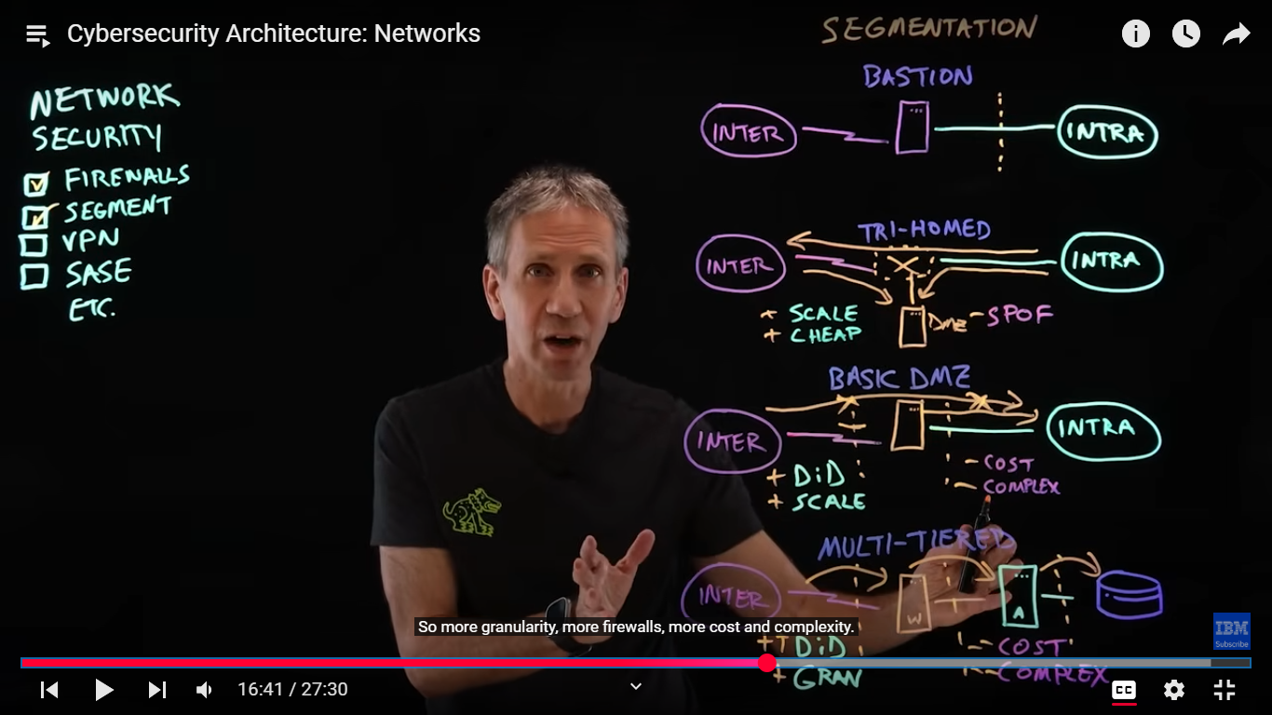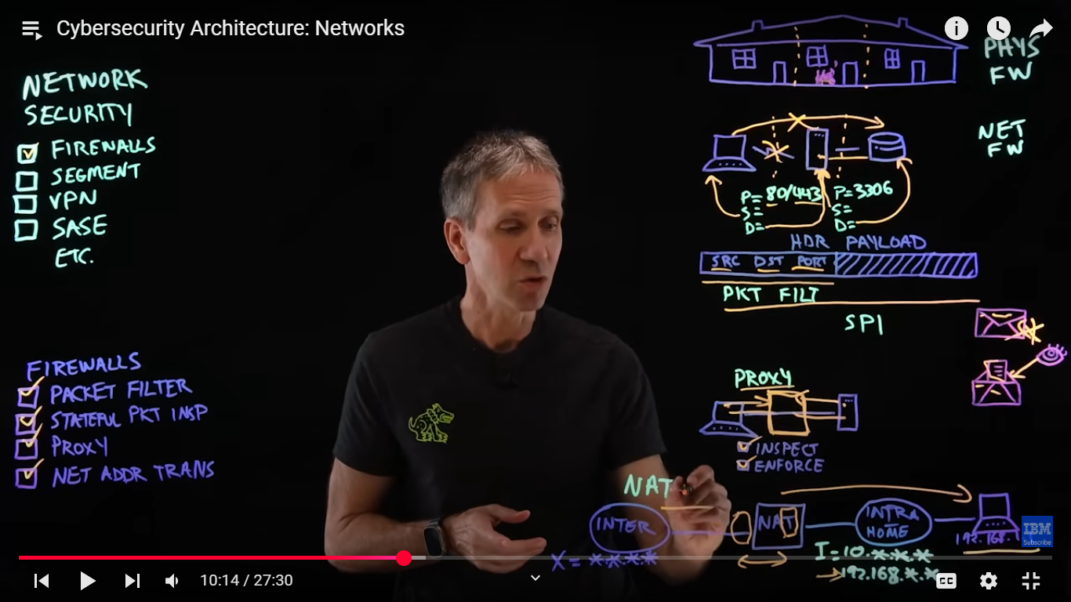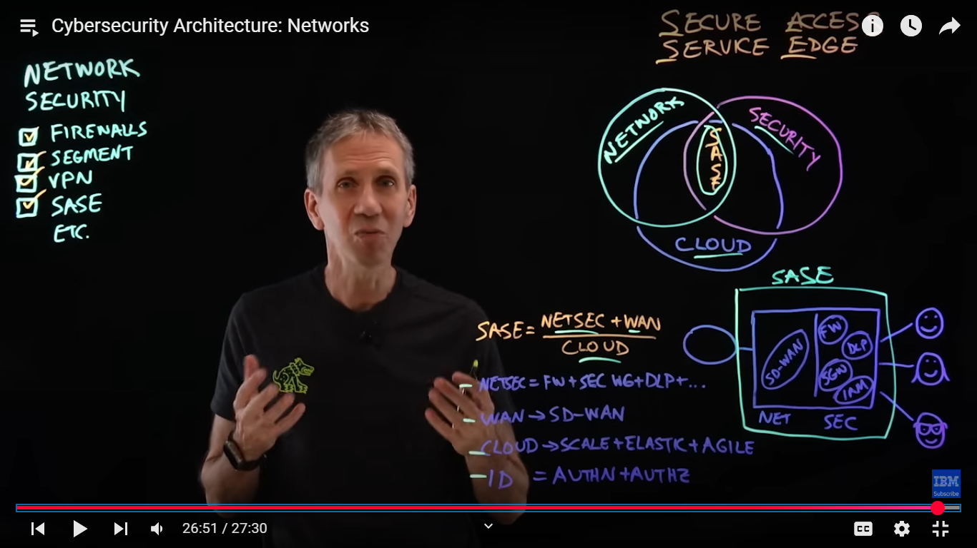

**SASE de tgme3thom kolhom swa b2aa**

**Application Security**

**LOG4J** de zi journal kda byb2a l developers byshofo l feedback bta3 l dev l tanyeen 3n l codes bta3thom w est5dmo ehh w eh l libraries l trusted w kda y3ni

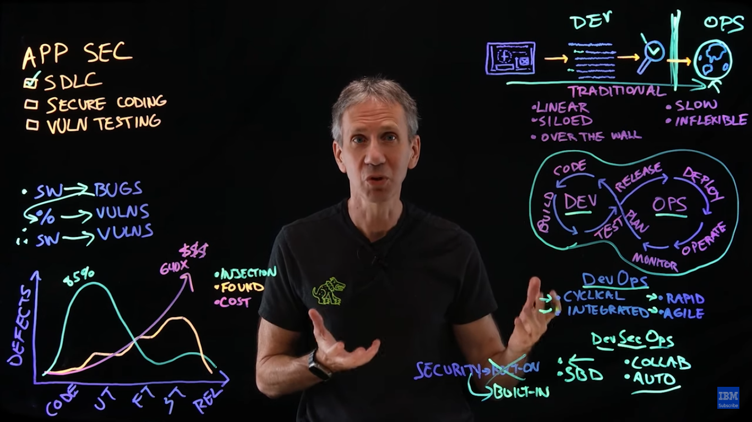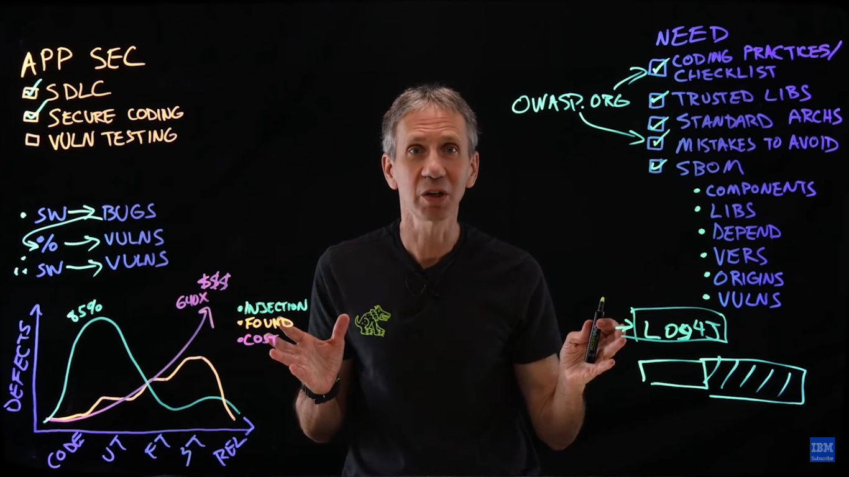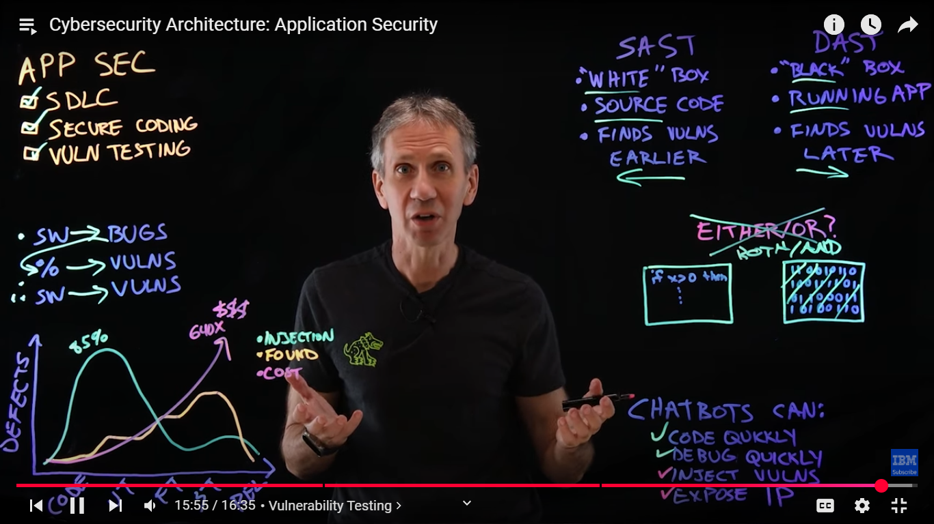

**Data Security**

